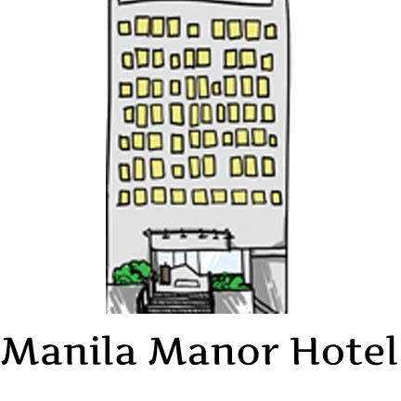

1660 Jorge Bocobo Street, Malate, Manila 1004, Philippines

***Greetings from Manila Manor Hotel your second home in Manila!***

***We would like to offer a special group rates for students.***

***Our rate as follow:***

***SUPERIOR ROOM***

***Twin Sharing Php 785/pax***

***Triple Sharing Php 535/pax***

***Quad Sharing Php 410/pax***

***Quin Sharing Php 335/pax***

***Student Meals:***

***Breakfast Php 68.00/pax***

***Lunch/Dinner Php 82.00/pax***

**Manila Manor Hotel** is conveniently located near the cultural and historical points of interest, minutes away from the business district of Makati and other top tourist attractions such as Chinatown, Intramuros, Rizal Park, and the nearest mall, the Robinsons Place Manila.

The hotel has a total of sixty-five (65) guests rooms furnished with basic amenities for your convenience. You may choose from the 3 room categories, **SUPERIOR, DELUXE and SUITE.**

While enjoying your stay, you can savor a delectable array of menu at the ***Café Luz*,** located at the lobby; it is open daily from 6:00 in the morning until 10:00 in the evening including the room service.

Private function rooms are available **for Banquets (debut, wedding reception) and Conference events, Live-in & Live-out Government / Private seminars, Corporate meetings**. We will ensure that your simplest occasion will turn out to be a memorable one. **“Give us your Budget and we will work on it.”**

The hotel also offers complimentary wi-fi, excellent quality service, 24-hour security, 24-hour standby generator, safety deposit boxes at reception and daily newspaper.

We hope that we have given you a glimpse of what you can expect when you stay at **Manila Manor Hotel.**

For your inquiries and reservations, please contactSales and Marketing Department thru our direct lines at Tel. no.(02)523-3259/533-1257 and Cel. No. (63) 09228982903, (02)525-9065 t0 69 (Front Desk) Fax: (02)524-9733, you may also send E-mail at: [manila.manorhotel@yahoo.com](mailto:manila.manorhotel@yahoo.com), Website: [www.themanilamanor.com](http://www.themanilamanor.com)

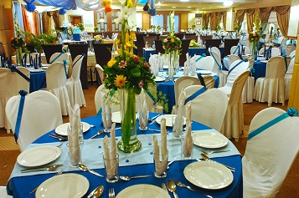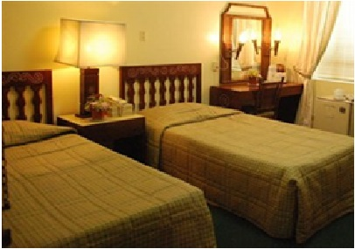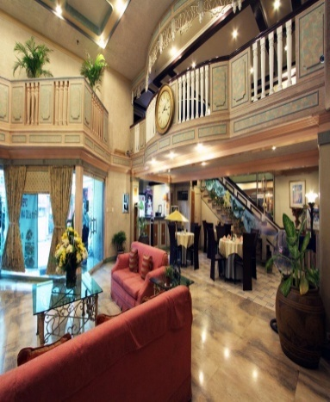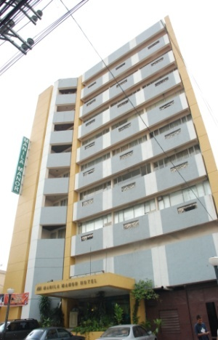

**Mezzanine**

**Superior Room**

**Hotel Lobby**

**Hotel Entrance**